## 

|  |  |
| --- | --- |
| Assignment Date | 1 october 2022 |
| Student Name | BALA KUAMR.V |
| Student Roll Number | 820419205012 |
| Maximum Marks | 2 Marks |

## sales by customer



C.Sales by Customer

CBN

Cadbury

LUTH

Mobil

NNPC

Customer

National Hospital

Nestle Shell Total Unilever

## 0 20 40 60 80 100 120 140 160 180 200 220 240 260 280

C.Sales (Sum)

sales by location

# C.Sales by C.Sales and Location

### C.Sales (Sum)

0 69

Aheokuta

Alauja I badan



### Location

Kacluna Lagos

I loi‘in

Port Harcourt

Warri

0

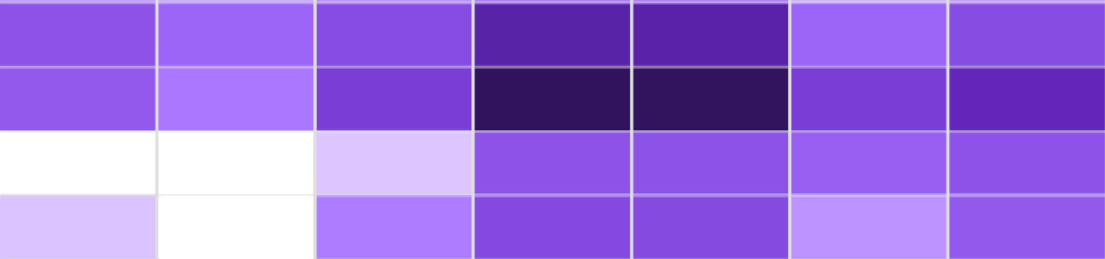2

3

C.Sales



7

8

9

10

sales by sales representative



# C.Sales by Sales Rep

### Sales Rep

@ A. Chukwu @ A. Oni @ S. Sunday @ P. Michaels @ M. Sule

received inventory for supplier

# Received Inventory for Supplier

Column values

@ lisci ease @ Decl ease @ Sum

2,000,000

1,500,000 

Received Inventory (Sum)

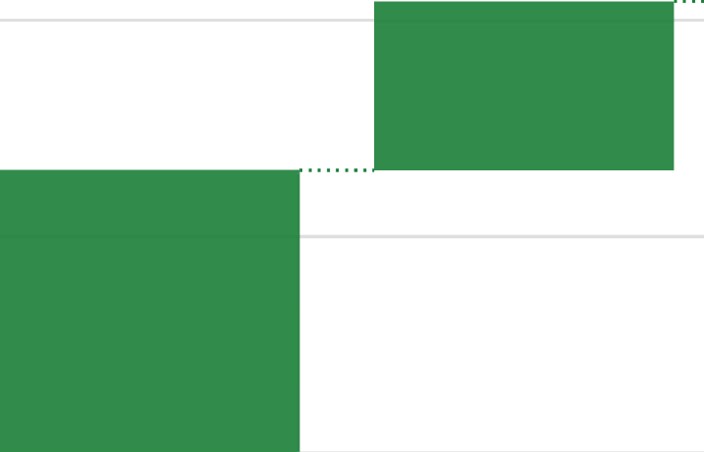1,000,000

500,000

0

Asti a Zeneca Novai-tis Pfizer Supplier

Sanofi Sum

## inventory stock for warehouse location

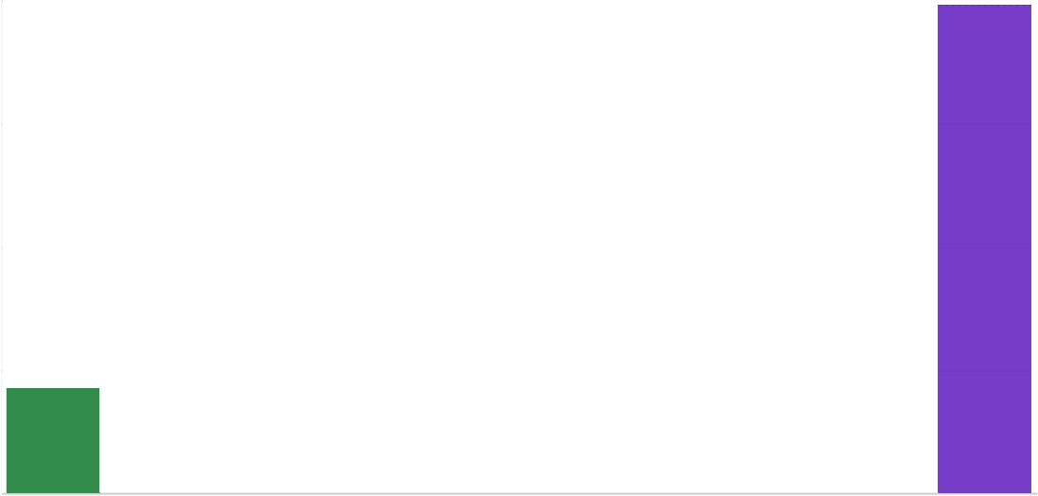

Inventory Stock for Warehouse Locations

Column values

@ Increase @ Decrease @ SLIM

400,000

300,000

200,000

100,000

0

Amuwo

Calabar

Ill TralJsit

Kano

Apapa Ikeja Kacluna Port Hal cou i I

Warehouse Locations

Inventory Stock (Sum)

sales trend

C.Sales by Actual

4.5

6.48

9.5

10.56

11.25

11.52

13.32

13.68

13.82

15.98

1ó.42

16.59

18.25

19.44

20.9

23.71

25.34

30.41

0 50

100

150

200

250

300

350

400

450

C.Sales (Sum)

Actual

sales by month

# M.Sales by Month

200

150

ł ł .Sales (Sum)

100

50

0

April

December

January

3une

May

October

August February July

March November Sept...

Month

actual, received inventory for month

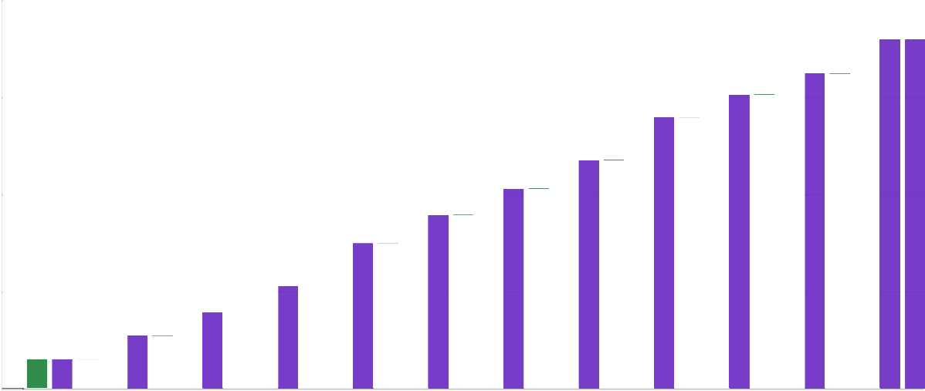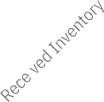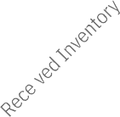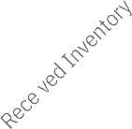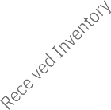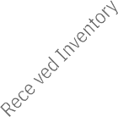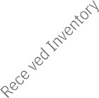

Actual and Received Inventory for Month

Column values

@ lisci ease @ Decl ease @ Sum

2,000,000

1,500,000

### 1,000,000

Values

500,000

0

Month